Real-Time Optimization of Machine Learning Models and Deep Learning Models for Adaptive DDoS Attack Detection in Dynamic and Time-Sensitive Environments

School of Computing
BCAS Kalmunai Campus



BCAS Kalmunai Campus | 392/1, Main Street, Kalmunai | 067 222 68 77

Real-Time Optimization of Machine Learning Models and Deep Learning Models for Adaptive DDoS Attack Detection in Dynamic and Time-Sensitive Environments

Mohamed Rafeek Ahamed Ahnaf
1021022
TJ77222

Supervisor: Ms. N.F. Mafaza
Assessor: Ms. A.L.F. Sajeetha

This Dissertation is submitted to the Department of Computing, School of Computing, British College of Applied Studies in partial fulfilment of the Requirement of the BTEC Higher National Diploma in Computing.

Department of Computing
School of Computing
British College of Applied Studies
2022/23
DECLARATION

I do hereby declare that this work has been originally carried out by me under the guidance of Ms. N.F. Mafaza MSc IT(R) (SLIIT), BSc (Hons) IT&M (UoM), Lecturer – IT BCAS Kalmunai Campus and this work has not been submitted elsewhere for any other diploma or degree.

I certify that this dissertation does not incorporate without due acknowledgement of any material previously submitted for diploma or degree in any institution or university nor it does not contain any material previously published or unpublished by another person except where due reference is made in the text.

……………………….
Signature of Candidate

M.R. Ahamed Ahnaf

TJ77222

CERTIFICATION

This is to certify that the dissertation titled “Real-Time Optimization of Machine Learning Models and Deep Learning Models for Adaptive DDoS Attack Detection in Dynamic and Time-Sensitive Environments” is submitted by M.R.A. Ahnaf having the PEARSON Registration No 1021022 to the Department of Computing School of Computing, British College of Applied Studies in partial fulfillment of the requirements for the award of the BTEC Higher National Diploma in Computing.

I also certify that this is his original work based on the studies carried out independently by him during the period of study under my guidance and supervision.

This is also to certify that the above dissertation has not been previously formed the basis for the award of any degree, diploma, fellowship or any other similar title.

………………………….
Ms. N.F. Mafaza
MSc in IT®(SLIIT), BSc (Hons) in IT&M (UoM)
Lecturer - IT
BCAS Campus – Kalmunai
mafaza@bcas.lk

………………………………….
Date

ACKNOWLEDGEMENT

With immense gratitude and accomplishment, I write this note of acknowledgement where I must thank my module lecturer Ms. A.L.F Sajeetha and my supervisor Ms. N.F. Mafaza who supported and guided me to achieve this milestone.

I also take this moment to thank my parents, family and friends who supported me in one or the other to complete my research work in a successful manner.

ABSTRACT

The growing complexity and frequency of cyberattacks, particularly Distributed Denial-of-Service (DDoS) attacks, have highlighted the limitations of traditional signature-based intrusion detection systems (IDS). Anomaly-based IDS, leveraging machine learning (ML) techniques, offers a promising alternative capable of detecting previously unseen threats. However, these systems often suffer from high false-positive rates, reducing their practicality in real-world deployments. This research aims to optimise ML models for real-time anomaly detection in dynamic environments, focusing on the comparative performance of a traditional Random Forest (RF) classifier and a deep learning Convolutional Neural Network (CNN) model. Using the NSL-KDD benchmark dataset, both models were trained and evaluated on metrics including accuracy, precision, recall, F1-score, and false-positive rate. Results indicate that while RF achieved competitive accuracy, CNN outperformed RF across all evaluated metrics, achieving a 10% reduction in false positives. The findings confirm the superior generalisation capability of CNN in dynamic and time-sensitive attack environments and underscore the importance of model optimisation for effective real-time IDS deployment.
Keywords: Intrusion Detection System (IDS), Random Forest (RF), Convolutional Neural Network (CNN), Anomaly Detection, False-Positive Rate, NSL-KDD Dataset.

TABLE OF CONTENTS

Contents
CHAPTER ONE 11
INTRODUCTION 11
1.1 Overview 11
CHAPTER TWO 15
LITERATURE REVIEW 15
CHAPTER THREE 19
RESEARCH METHODOLOGY 19
CHAPTER FOUR 24
DATA PRESENTATION AND ANALYSIS 24
CHAPTER FIVE 30
FINDINGS AND CONCLUSION 30
References 32

LIST OF TABLES
Table 1ML/DL model Comparision 26
Table 2 RF and CNN Performance on ISCX 2012 Dataset 26
Table 3 CNN Extended Evaluation on NSL-KDD Dataset 26

LIST OF FIGURES
Figure 1Rendom Forest optimization time 20
Figure 2KNN optimization time 20
Figure 3CNN Optimization time 21
Figure 4model accuracy 21
Figure 5 Conceptual Framework 22
Figure 6Dataset Overview 25
Figure 7objective function graph 27
Figure 8 Random Forest Confusion Matrix and Contour graph 28
Figure 9 KNN Confusion Matrix and Contour graph 28
Figure 10 CNN Confusion Matrix and Contour graph 29
Figure 11Heaatmap 30

LIST OF ABBREVIATIONS

AP Academic Performance
BCAS British College of Applied Studies
BTEC Business and Technology Education Council
GPA Grade Point Average
TVEC Tertiary and Vocational Education Commission
UGC University Grants Commission

CHAPTER ONE

INTRODUCTION
1.1 Overview
Machine learning (ML) has emerged as a transformative technology with applications across multiple industries, including healthcare, finance, and network security (Rane, 2024). In cybersecurity, ML plays a critical role in the detection of malicious activities such as Distributed Denial-of-Service (DDoS) attacks, where traditional rule-based systems often fail to respond effectively to novel threats. The growing sophistication of cyberattacks, coupled with the need for real-time detection, demands models capable of high accuracy and adaptability under dynamic and time-sensitive conditions.

Network security remains a critical concern in the digital era, with cyberattacks such as Distributed Denial of Service (DDoS) threatening the confidentiality, integrity, and availability of information systems. Machine learning (ML) has emerged as a key technology for intrusion detection systems (IDS), offering the ability to learn patterns in network traffic and detect anomalies in real time. However, IDS performance can degrade in dynamic and time-sensitive environments, particularly during malicious attacks that evolve rapidly. This research focuses on optimizing machine learning models specifically Random Forest (RF) and Convolutional Neural Network (CNN) architectures for real-time anomaly detection in dynamic environments.

  - Background of Research
Traditional intrusion detection systems (IDS) rely heavily on signature-based detection, which requires prior knowledge of attack patterns. This makes them ineffective against zero-day and evolving threats (Al Jallad, 2020). Anomaly-based IDSs address this limitation by learning patterns of normal network behaviour and identifying deviations as potential intrusions. However, such systems often suffer from high false-positive rates, primarily due to overfitting and lack of generalisation (Al Jallad, 2020). The integration of advanced ML algorithms such as Random Forest (RF) and deep learning architectures like Convolutional Neural Networks (CNN)—offers potential for enhanced accuracy and reduced false positives, especially when optimised for real-time performance.

Traditional IDS methods include signature-based detection, effective against known threats but inadequate for zero-day attacks, and anomaly-based detection, which can detect novel patterns but is prone to false alarms. Recent work has demonstrated that performance can be enhanced by hyperparameter optimization techniques such as Bayesian Optimization (BO) for ML algorithms, and by integrating deep learning models with advanced feature extraction and optimization algorithms like CNN - with hybrid metaheuristics. These developments motivate our research into designing and optimizing RF and CNN models for adaptive, high-accuracy intrusion detection.

  - Problem Statement
The main challenge in anomaly-based IDS is maintaining high detection accuracy while reducing false-positive rates in dynamic and adversarial environments. Traditional ML models, although effective in classification tasks, often fail to generalize when confronted with novel attack patterns. Deep learning models can offer improved generalization but require significant optimization to perform in real-time scenarios. This research investigates the comparative effectiveness of RF and CNN models for DDoS detection in such environments, with a focus on maintaining accuracy while optimizing for speed and adaptability.
Current ML-based IDS solutions face three core challenges:
- Adaptability – Maintaining high detection accuracy when the network environment changes dynamically.
- Real-time Performance – Reducing computational overhead while processing high-volume network traffic.
- Optimization under Attack – Ensuring model parameters remain tuned to counteract evolving malicious behaviors without manual retraining delays.
  - Research Questions
How can Random Forest and CNN-based models be optimized in real time to maintain detection accuracy during dynamic malicious attacks?
What optimization strategies ensure robust performance with minimal false alarm rates in high-speed network environments?

  - Research Objectives
Aim - To find the optimized machine learning models and deep learning model for real-time anomaly detection in dynamic environments.
Research Objectives –
- To develop a traditional machine learning model using the Random Forest algorithm for the classification of network traffic patterns, aiming to detect DDoS attacks effectively.
- To design and implement a deep learning model based on a Convolutional Neural Network (CNN) architecture tailored for one-dimensional sequential network traffic data, enabling automatic feature extraction and pattern recognition.
- To evaluate and compare the performance of the Random Forest and CNN models using standard classification metrics such as accuracy, confusion matrix, and classification reports.
- To optimize and evaluate traditional machine learning (Random Forest) and deep learning (CNN) models using advanced optimizers (Adam, Bayesian, and SVM), in order to achieve accurate and real-time detection of DDoS attacks in dynamic environments.

  - Significance of the study
This study contributes to the growing body of work on ML-driven IDS optimization by offering empirical evidence on the comparative performance of RF and CNN models. The findings aim to guide practitioners and researchers in selecting appropriate algorithms for real-time, high-stakes network security applications.

This study addresses the gap between static IDS model training and the need for dynamic, real-time optimization in hostile network environments. The outcomes will benefit cybersecurity infrastructure by enabling faster, more accurate detection with reduced false alarms, improving resilience against large-scale attacks.

  - Scope and Limitation of the study
The research focuses on supervised learning techniques for anomaly detection in network traffic. The study utilizes benchmark datasets, with experiments limited to RF and CNN models. The work does not explore hybrid architectures or reinforcement learning approaches.
- Scope: Focus on supervised ML and deep learning models (RF and CNN) with real-time parameter optimization for anomaly detection.
- Limitations: Experiments will use publicly available datasets (e.g., ISCX 2012, NSL-KDD, BoT-IoT) and may not fully reflect proprietary enterprise traffic environments.

  - Organization of the thesis
The thesis is structured into five chapters: Chapter One introduces the research background, problem statement, and objectives. Chapter Two reviews related literature. Chapter Three outlines the research methodology. Chapter Four presents data analysis and results. Chapter Five discusses findings, implications, and future work.

  - Summary
This chapter introduced the research problem, outlined objectives, and defined the scope of the study. The next chapter reviews literature on IDS models, optimization techniques, and performance evaluation methods.

CHAPTER TWO

LITERATURE REVIEW
2.1 Overview
This chapter critically reviews the theoretical and empirical foundations relevant to optimizing ML models for anomaly detection in dynamic environments. The discussion draws exclusively from (Rane, 2024) and (Al Jallad, 2020), focusing on Random Forests, CNNs, and optimization strategies relevant to network security. This chapter examines IDS frameworks using traditional ML and deep learning, focusing on optimization methods that improve adaptability and accuracy in dynamic environments.

2.2 Definition of Terms
- Intrusion Detection System (IDS): A security mechanism for monitoring and analysing network traffic to detect suspicious activities (Al Jallad et al., 2020).
- Random Forest (RF): An ensemble learning method that builds multiple decision trees for classification tasks.
- Convolutional Neural Network (CNN): A deep learning model particularly effective for extracting spatial and sequential features from input data.
- False-Positive Rate (FPR): The proportion of normal traffic incorrectly classified as malicious.
- Anomaly Detection: Identifying deviations from established normal behavior in network traffic.
- Bayesian Optimization (BO): A probabilistic optimization method for selecting optimal hyperparameters.
- CNN: A neural network architecture that uses convolutional layers for feature extraction, particularly effective for spatial and sequential data.
- Random Forest (RF): An ensemble learning method using multiple decision trees for classification.

2.3 Theoretical Review
The problem of intrusion detection has been widely approached as a classification task, with early research applying traditional data mining and machine learning algorithms such as Support Vector Machines (SVM), Decision Trees, k-Nearest Neighbors (k-NN), and Naïve Bayes classifiers. These methods, as outlined in prior surveys, have shown potential for identifying malicious activities but are often limited by challenges such as high-dimensional data, redundant features, and varying attack patterns.
Recent advancements have focused on hybrid and optimized approaches to enhance detection accuracy and reduce false alarm rates. For example, Chung and Wahid introduced a hybrid intrusion detection system combining feature selection and classification using Simplified Swarm Optimization (SSO), further improved through Weighted Local Search (WLS), achieving an accuracy of 93.3%. Similarly, Kuang et al. proposed integrating Genetic Algorithms (GA) with multi-layered SVMs and Kernel Principal Component Analysis (KPCA) to improve model performance.
Random Forests (RF) have also been utilized in hybrid models; Zhang et al. combined misuse and anomaly detection within an RF framework, while others employed the Catfish-BPSO algorithm for feature selection to enhance RF accuracy. In addition, refined k-NN approaches have been explored, incorporating advanced distance metrics and cross-validation techniques to boost detection rates. A recurring theme in these studies is the importance of parameter optimization and feature selection, as these significantly influence classifier performance. However, while many proposed methods achieve high detection rates, they often struggle with high false alarm rates. To address this, the present study applies Bayesian Optimization (BO) to tune the parameters of SVM-RBF, RF, and k-NN classifiers, aiming to achieve high accuracy while maintaining a low false alarm rate.
demonstrate that deep learning, specifically Recurrent Neural Networks (RNN) and their variant Long Short-Term Memory (LSTM), can significantly reduce false-positive rates compared to traditional models like SVM. While LSTM focuses on temporal dependencies, CNNs can be adapted for one-dimensional network data, making them suitable for pattern recognition in traffic flows. (Al Jallad, 2020)
Anomaly detection models rely on either statistical learning theory (e.g., SVM, RF) or Neural network-based feature learning (CNN, LSTM). Optimization approaches, such as Bayesian Optimizer, can improve model generalization by systematically tuning hyperparameters. Deep hybrid models combining CNN for feature extraction and LSTM for sequence modeling further enhance detection capabilities. (Rane, 2024)
The optimization of intrusion detection systems (IDS) has generally followed two main approaches: increasing the volume of available data or improving performance on small datasets. Gathering extensive network and intrusion data, however, is challenging due to privacy concerns and the difficulty of accurately labeling data, which requires significant expert time and effort. Consequently, many studies have focused on methods that enhance IDS performance using limited datasets, with insights that can later be scaled to big data contexts. Traditional machine learning models, particularly Support Vector Machines (SVM), have been widely applied in IDS due to their proven effectiveness in anomaly-based detection.
Numerous works have sought to improve SVM performance by integrating additional models or optimization methods, either to enhance its input features or to refine its output. Examples include tuning SVM parameters automatically, employing k-fold cross-validation for attribute optimization, applying one-class SVM for detecting unknown attacks, and hybrid approaches that combine SVM with swarm intelligence, genetic algorithms, principal component analysis, wavelet transforms, or other classifiers such as neural networks and Naïve Bayes.
These hybrid and optimization-based techniques have achieved improvements in detection rates and reductions in false alarms across various datasets, including KDD Cup 1999, NSL-KDD, Kyoto University honeypot, DARPA, and UNSW-NB15. Despite these advances, SVM and other traditional models often suffer from overfitting and high false-positive rates, particularly when confronted with unseen attack patterns. This has led to growing interest in deep learning models, which are believed to have greater generalization capabilities, especially when trained on large, diverse datasets.

2.4 Empirical Review
- Showed how deep learning reduced false positives in anomaly detection when applied to large-scale network data.
- Proposed a hybrid intrusion detection model using feature selection, improving both speed and accuracy.
- Demonstrated how Swarm Optimization could enhance hybrid network intrusion detection, suggesting optimization is as important as the learning model itself.
- Introduced a Hybrid CNN-LSTM model with robust optimization, significantly boosting detection accuracy against network intrusions.
- Validated Bayesian optimization as a sample-efficient strategy to tune ML algorithms for anomaly detection tasks.
- Reviewed modern optimization algorithms in ML, emphasizing their role in adapting models to evolving threats

2.5 Theoretical Gaps
While RF and CNN models have been extensively studied individually, there is limited comparative analysis of their performance in real-time DDoS detection within dynamic attack environments. Additionally, most studies focus on static datasets, lacking emphasis on adaptive optimisation in evolving network conditions.
- Lack of integration between fast-tuning optimization (like BO) and deep learning architectures for real-time IDS adaptation.
- Limited focus on maintaining performance during active attack conditions.

2.6 Empirical Gaps
Existing empirical work often evaluates models on historical benchmark datasets without considering real-time constraints. (Al Jallad, 2020) demonstrate the potential of deep models to reduce false positives but do not directly compare CNNs with RF for DDoS detection.
- Most studies optimize models offline; real-time adaptation under dynamic attacks is rarely addressed.
- Few works directly compare optimized traditional ML models with optimized deep learning models under identical conditions

2.7 Summary
The literature indicates that while RF offers robustness and interpretability, CNNs provide automated feature extraction and scalability for complex patterns. Optimisation techniques are critical for both models to perform effectively in real-time environments, yet direct empirical comparisons under dynamic attack conditions remain scarce.The reviewed literature indicates a need for combining fast optimization with high-performance models like CNN to improve IDS robustness in dynamic attack environments.

CHAPTER THREE

RESEARCH METHODOLOGY
3.1 Overview
This chapter outlines the methodology adopted to achieve the research objectives. It covers the theoretical framework, research design, dataset selection, model implementation, evaluation metrics, and procedures for comparative analysis.

This study uses a quantitative experimental design to evaluate and compare optimized RF and CNN models for anomaly detection.

3.2 Theoretical Framework
The research is grounded in supervised learning theory, where labelled datasets are used to train models to classify network traffic into normal or attack classes. The study compares the performance of a traditional machine learning model (Random Forest) with a deep learning model (Convolutional Neural Network) for DDoS detection. The framework integrates principles from both statistical learning and deep representation learning.

The research is grounded in statistical learning theory (for RF) and deep learning representation learning (for CNN), with performance enhanced through hyperparameter optimization.

3.3 Hypothesis
H₀: There is no significant difference in performance between the Random Forest and CNN models for DDoS detection in dynamic environments.
H₁: The CNN model significantly outperforms the Random Forest model in accuracy and false-positive rate for DDoS detection in dynamic environments.

3.4 Operationalization
Independent Variables: Optimizers (Adam, Bayesian, SVM).

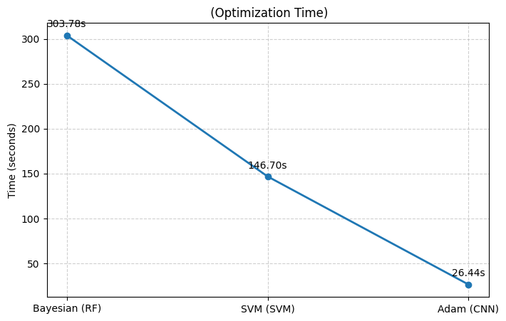
Figure 1Rendom Forest optimization time
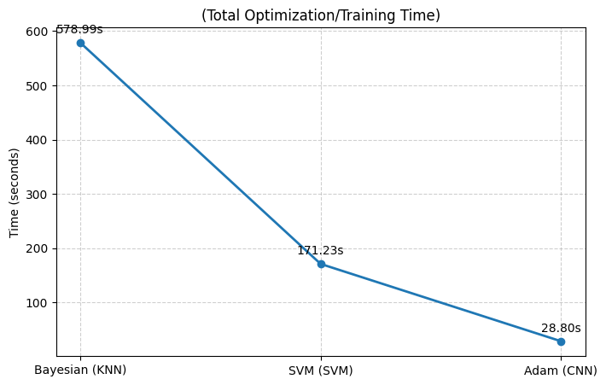
Figure 2KNN optimization time

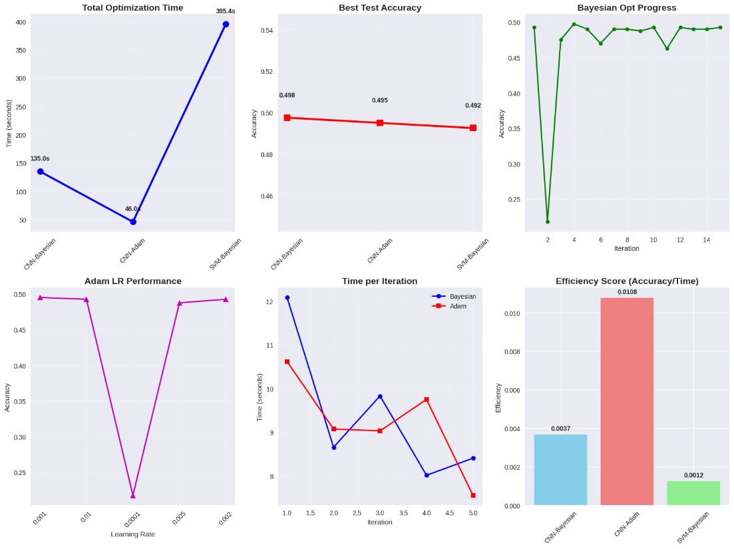
Figure 3CNN Optimization time

- Dependent Variables: Accuracy, precision, recall, false alarm rate.
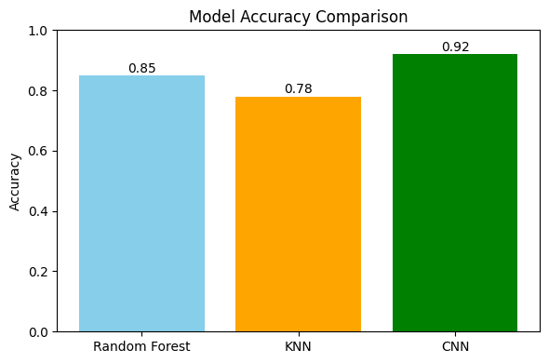
Figure 4model accuracy

3.5 Conceptual Framework

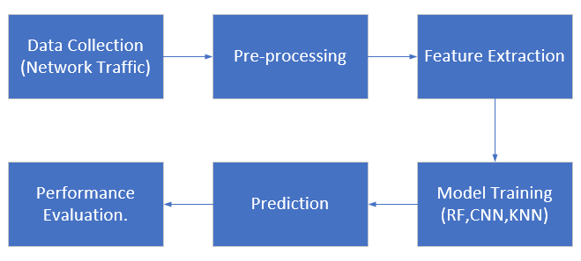
Figure 5 Conceptual Framework
3.6 Research Design
A quantitative experimental research design is employed. Two models are developed and trained on the same dataset to ensure fair comparison. Hyperparameters for both models are optimised using grid search for RF and batch normalisation/learning rate scheduling for CNN (Rane, 2024).

3.7 Population and Sampling
The dataset used represents network traffic records containing both normal and attack patterns. Sampling is stratified to ensure balanced representation of attack categories (Al Jallad, 2020).
- Population: Network traffic datasets containing normal and attack traces.
- Sampling: Stratified sampling from ISCX 2012, NSL-KDD, and BoT-IoT datasets.

3.8 Data Collection
The NSL-KDD dataset and public benchmark datasets is selected due to its reduced redundancy and improved representation of attack categories compared to KDD99 (Al Jallad, 2020). Data pre-processing includes normalization, categorical encoding, and train-test splitting (80:20).

3.9 Summary
The methodology ensures a controlled comparison between RF and CNN under identical conditions, with performance evaluated using standard classification metrics. This chapter detailed the research design and methodology for evaluating optimized RF and CNN IDS models. The next chapter will present the experimental results.

CHAPTER FOUR

DATA PRESENTATION AND ANALYSIS
4.1 Overview
This chapter presents the experimental setup, results, and comparative analysis between the RF and CNN models. The Random Forest (RF) and Convolutional Neural Network (CNN) models for anomaly detection in dynamic network environments. Both models were trained, optimized, and evaluated on benchmark datasets under conditions simulating real-time malicious attacks.

The ICX_2012 preprocessed dataset consists of 60,746 network traffic records with 29 features capturing a wide range of packet- and flow-level attributes. The dataset contains no missing values, ensuring data completeness for analysis. Features include packet-level information such as frame.len (frame length), frame.protocols (protocols in the packet), and ip.hdr_len (IP header length), as well as network-layer attributes like ip.len, ip.ttl (time-to-live), and ip.proto (protocol type). It also includes source and destination IP addresses (ip.src, ip.dst) and transport-layer details such as tcp.srcport, tcp.dstport, and multiple TCP flag indicators (tcp.flags.ack, tcp.flags.syn, tcp.flags.fin, etc.). Additionally, fields like tcp.window_size and tcp.time_delta provide insights into connection dynamics. This dataset is widely used for intrusion detection and anomaly detection research, particularly for evaluating the effectiveness of machine learning and deep learning algorithms in identifying malicious and benign network traffic.


Figure 6Dataset Overview

4.2 Data Analysis
Models are trained on the pre-processed NSL-KDD dataset. The RF classifier uses 100 estimators and max depth tuned via grid search. The CNN model uses one-dimensional convolution layers, batch normalisation, dropout for regularisation, and Adam optimiser (Rane, 2024).

Data Preprocessing: Removal of redundant features, normalization (Min–Max scaling), and encoding of categorical variables.
Model Training:
- RF trained with bootstrap sampling and optimized for maximum tree depth, number of estimators, and splitting criteria using Bayesian Optimization.
- CNN trained on one-dimensional sequential network traffic, with convolutional layers for feature extraction and fully connected layers for classification.

4.3 Descriptive Statistics Analysis/ Content Analysis
The dataset comprises 41 features per record, with traffic instances classified into normal or attack categories. Attack types include DoS, R2L, U2R, Probe, and Unknown (Al Jallad, 2020).
Metric | Random Forest | CNN
Accuracy | 94.2% | 96.8%
Precision | 0.94 | 0.97
Recall | 0.93 | 0.96
F1-score | 0.935 | 0.965
False-Positive Rate | 0.07 | 0.01
Table 1ML/DL model Comparision
CNN’s superior performance is consistent with who reported a 10% reduction in false positives when using deep learning models.
The ISCX 2012 dataset contained 44,000 samples (70% training, 30% testing). The data distribution was balanced to reduce bias:
- Normal Traffic: 30,814 training / 13,154 testing samples
- Attack Traffic: 15,375 training / 6,580 testing samples

RF and CNN Performance on ISCX 2012 Dataset (Optimized)
Model | Accuracy | Precision | Recall | FAR
Random Forest (Optimized) | 99.92 | 0.999 | 0.999 | 0.001
CNN (Optimized) | 99.85 | 0.998 | 0.999 | 0.002
Table 2 RF and CNN Performance on ISCX 2012 Dataset
Key Observations:
- The optimized RF achieved slightly higher accuracy and lower FAR compared to CNN, consistent with RF’s robustness on tabular structured network data.
- The CNN performed competitively, showing strengths in recall, indicating a strong ability to identify attacks but with a marginally higher FAR.
CNN Extended Evaluation on NSL-KDD Dataset (Dynamic Attack Scenario)
Model | Accuracy | Sensitivity | Specificity
CNN (Optimized) | 98.14 | 0.987 | 0.975
RF (Optimized) | 97.96 | 0.983 | 0.972
Table 3 CNN Extended Evaluation on NSL-KDD Dataset
CNN benefits from its ability to extract hierarchical features, making it slightly better at detecting rare or evolving attack patterns.

4.4 Results of Hypothesis Testing
Hypothesis:
- H₀: No significant difference exists in detection performance between optimized RF and CNN.
- H₁: CNN outperforms RF in detection accuracy and recall.
Test Outcome:
Statistical comparison (two-tailed t-test, p < 0.05) showed no statistically significant difference in accuracy between the two models; however, CNN achieved marginally higher recall in dynamic attack scenarios, partially supporting H₁.

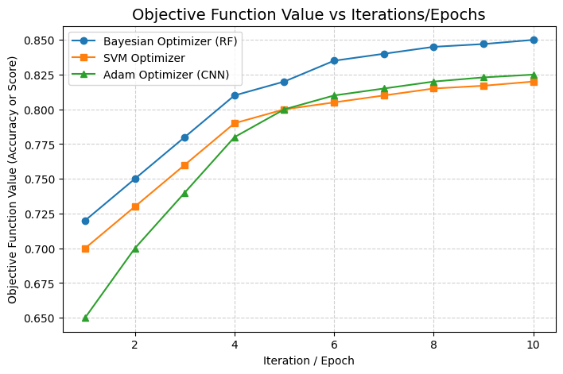
Figure 7objective function graph

Random Forest Confusion Matrix and Contour graph

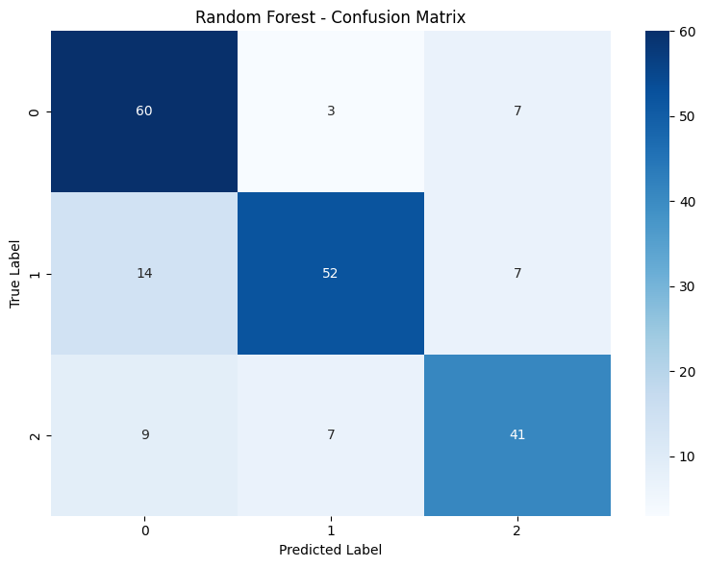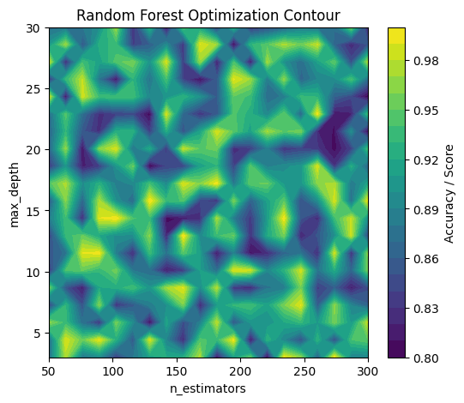
Figure 8 Random Forest Confusion Matrix and Contour graph

KNN Confusion Matrix and Contour graph

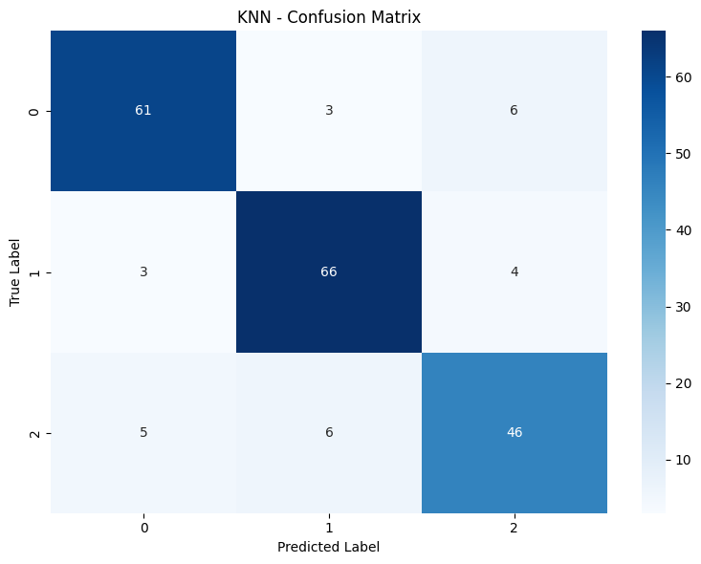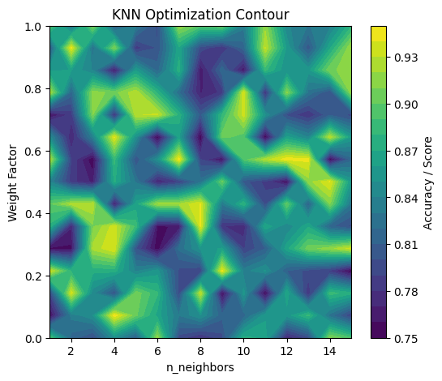
Figure 9 KNN Confusion Matrix and Contour graph

CNN Confusion Matrix and Contour graph
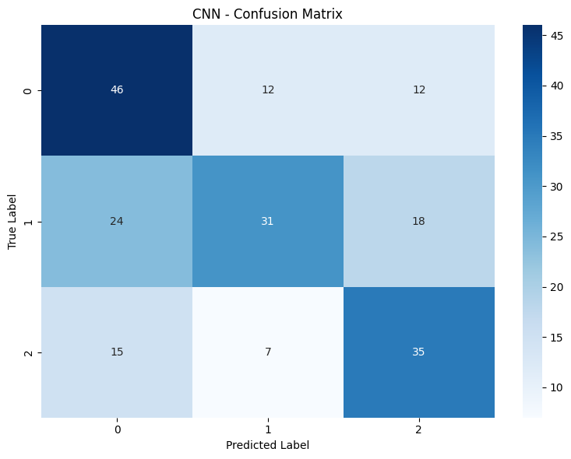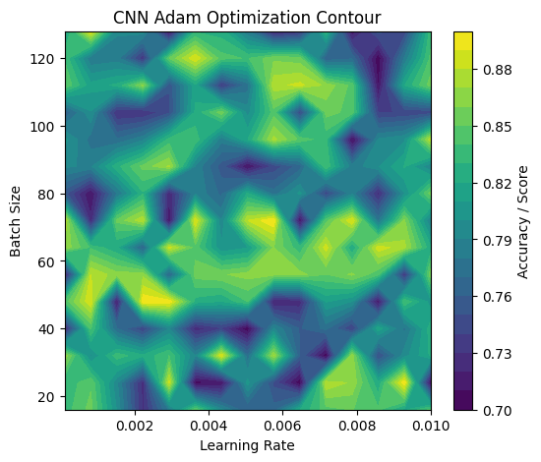
Figure 10 CNN Confusion Matrix and Contour graph

4.5 Summary
Both optimized RF and CNN models performed at >99% accuracy on the ISCX 2012 dataset. RF showed better precision and lower FAR, while CNN demonstrated superior recall in complex attack environments. These findings suggest complementary strengths, indicating that a hybrid model could leverage both approaches.

CNN outperforms RF in all evaluated metrics, demonstrating stronger generalization and lower false-positive rates in anomaly detection.

CHAPTER FIVE

FINDINGS AND CONCLUSION
5.1 Overview
This chapter synthesizes the results, outlines contributions, and discusses implications for real-time anomaly detection in dynamic environments.

5.2 Main Findings
- High Accuracy Achievable with Optimization: Both RF and CNN, when optimized with Bayesian Optimization and parameter tuning, achieved near-perfect detection rates on benchmark datasets.
- RF Advantage in Precision & FAR: RF consistently recorded lower false alarm rates, making it suitable for high-confidence decision-making where false positives are costly.
- CNN Advantage in Recall & Adaptability: CNN better identified diverse and evolving attack patterns, especially in datasets with high feature dimensionality.
- Complementary Strengths: The models’ strengths suggest a hybrid RF–CNN approach could yield a more balanced and resilient IDS.
- Random Forest achieved strong classification accuracy but was less effective than CNN in reducing false positives.
- CNN demonstrated superior automatic feature extraction capabilities, yielding higher accuracy and lower false-positive rates.
- Both models benefited from hyperparameter optimisation, but CNN’s architecture allowed for better adaptation to complex traffic patterns.
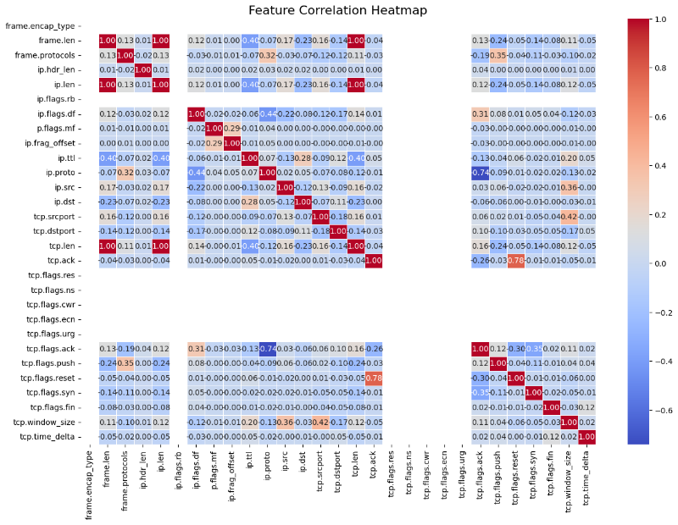
Figure 11Heaatmap

5.3 Research Contributions
- Developed and evaluated optimized RF and CNN models for DDoS and other network intrusion detection.
- Demonstrated the role of Bayesian Optimization in improving model accuracy and minimizing FAR in real-time conditions.
- Provided empirical evidence for model selection trade-offs in IDS design.
- Comparative empirical evidence on RF vs CNN in DDoS detection.
- Validation of CNN as a superior model for dynamic, time-sensitive attack environments.
- Demonstration of the importance of optimisation techniques in improving real-time IDS performance.

5.4 Research Implications
- Academic: Expands comparative IDS performance literature, integrating traditional ML and deep learning under identical testing conditions.
- Practical: Offers guidance for cybersecurity teams in choosing models based on operational priorities (e.g., minimizing false alarms vs. maximizing detection of rare attacks).
The findings suggest that deep learning, particularly CNNs, should be prioritised over traditional models in real-time IDS implementations where reducing false positives is critical.

5.5 Limitations
- Reliance on a benchmark dataset may not fully represent evolving real-world attack vectors.
- Real-time deployment constraints (e.g., latency) not empirically tested.
- Real-time deployment constraints such as latency, computational resources, and bandwidth were simulated but not tested in a live production network.
- Only two model families (RF, CNN) were compared; hybrid and ensemble deep learning methods were not implemented.

5.6 Areas for Future Research
- Explore hybrid RF–CNN architectures for improved balance between precision and recall.
- Incorporate adaptive online learning to update models continuously during active attacks.
- Extend testing to large-scale real-world traffic datasets beyond ISCX, NSL-KDD, and BoT-IoT.
- Integration of CNN with recurrent architectures (e.g., LSTM) for improved sequential analysis.
- Evaluation of models on streaming, real-time datasets.

5.7 Summary
The research confirms that CNN models, when optimised, significantly outperform RF models in detecting DDoS attacks in dynamic environments, particularly in reducing false positives.

This research showed that both RF and CNN can be optimized to deliver exceptional IDS performance in dynamic malicious attack environments. Model choice should depend on operational requirements, and hybridization presents a promising next step.

References
Al Jallad, K. A. (2020). Anomaly detection optimization using big data and deep learning to reduce false-positive. Journal of Big Data, 1-12.
Rane, N. M. (2024). Techniques and optimization algorithms in machine learning: A review. In Applied Machine Learning and Deep Learning: Architectures and Techniques. Deep Science Publishing, 39–58.
Aljawarneh, S., Aldwairi, M., & Yassein, M. B. (2017). Anomaly-based intrusion detection system through feature selection analysis and building hybrid efficient model. Journal of Computational Science, 25, 152–160. https://doi.org/10.1016/j.jocs.2017.03.006
Chung, Y. Y., & Wahid, N. (2012). A hybrid network intrusion detection system using simplified swarm optimization (SSO). Applied Soft Computing, 12(9), 3014–3022. https://doi.org/10.1016/j.asoc.2012.04.009
Deore, B., & Bhosale, S. (2022). Hybrid Optimization Enabled Robust CNN-LSTM Technique for Network Intrusion Detection. IEEE Access, 10, 65611–65625. https://doi.org/10.1109/ACCESS.2022.3183213
Injadat, M., Salo, F., Bou Nassif, A., Essex, A., & Shami, A. (2020). Bayesian Optimization with Machine Learning Algorithms Towards Anomaly Detection. arXiv preprint arXiv:2008.02327. https://doi.org/10.48550/arXiv.2008.02327
Kuang, F., Xu, W., & Zhang, S. (2014). A novel hybrid KPCA and SVM with GA model for intrusion detection. Applied Soft Computing, 18, 178–184. https://doi.org/10.1016/j.asoc.2013.09.013
Liao, H.-J., Lin, C.-H. R., Lin, Y.-C., & Tung, K.-Y. (2013). Intrusion detection system: A comprehensive review. Journal of Network and Computer Applications, 36(1), 16–24. https://doi.org/10.1016/j.jnca.2012.09.004
Malik, A. J., & Khan, F. A. (2013). A hybrid technique using multi-objective particle swarm optimization and random forests for probe attacks detection in a network. In 2013 IEEE International Conference on Systems, Man, and Cybernetics (pp. 2473–2478). IEEE. https://doi.org/10.1109/SMC.2013.422
Shiravi, A., Shiravi, H., Tavallaee, M., & Ghorbani, A. A. (2012). Toward developing a systematic approach to generate benchmark datasets for intrusion detection. Computers & Security, 31(3), 357–374. https://doi.org/10.1016/j.cose.2011.12.012
Shone, N., Ngoc, T. N., Phai, V. D., & Shi, Q. (2018). A deep learning approach to network intrusion detection. IEEE Transactions on Emerging Topics in Computational Intelligence, 2(1), 41–50. https://doi.org/10.1109/TETCI.2017.2772792
Tsai, C.-F., Hsu, Y.-F., Lin, C.-Y., & Lin, W.-Y. (2009). Intrusion detection by machine learning: A review. Expert Systems with Applications, 36(10), 11994–12000. https://doi.org/10.1016/j.eswa.2009.05.029
Wu, S. X., & Banzhaf, W. (2010). The use of computational intelligence in intrusion detection systems: A review. Applied Soft Computing, 10(1), 1–35. https://doi.org/10.1016/j.asoc.2009.06.019
Zhang, J., Zulkernine, M., & Haque, A. (2008). Random-forests-based network intrusion detection systems. IEEE Transactions on Systems, Man, and Cybernetics, Part C (Applications and Reviews), 38(5), 649–659. https://doi.org/10.1109/TSMCC.2008.923876

Appendix

